PF LAB ASSignment #5

Mohammad Yehya , 21K-3309

Table of Contents

Question #1 2

Question #2 3

Question #3 4

Question #4 5

Question #5 7

Question #6 8

Question #7 10

Question #8 12

Question #9 14

# Question #1

#include <stdio.h>

int main(){

//Q1

int num;

printf("Please enter a number: ");

scanf("%d",&num);

if (num%3 == 0 && num%6 == 0)

{

printf("This number is a multiple of 6 and 3");

}

else

{

(printf("This number is not a multiple of 6 and 3 "));

}

}

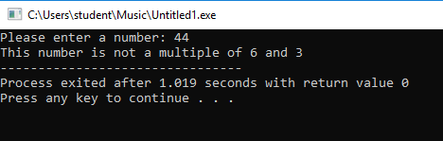

# Question #2

#include <stdio.h>

int main(){

//Q2

int hrs;

printf("Please enter time of the day in 24 hour system: ");

scanf("%d",&hrs);

switch(hrs){

case 5 ... 11:

printf("Good Morning");

break;

case 12 ... 18 :

printf("Good Evening");

break;

case 19 ... 24 :

printf("Good Night");

break;

default:

printf("Invalid Input");

break;

}

}

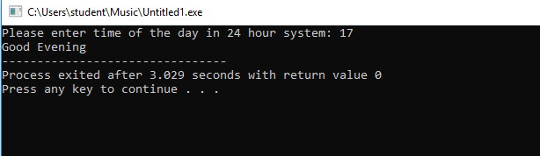

# Question #3

#include <stdio.h>

int main(){

//Q3

float a1,a2,a3;

printf("Please enter the angles of a triagle");

printf("\nAngle 1 = ");

scanf("%f", &a1);

printf("Angle 2 = ");

scanf("%f", &a2);

printf("Angle 3 = ");

scanf("%f", &a3);

if ((a1 + a2 + a3) == 180)

printf("It is a valid triangle");

else

printf("Not a valid triangle");

}

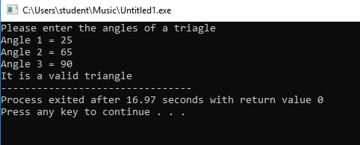

# Question #4

#include <stdio.h>

int main(){

//Q4

float op1,op2;

char oper;

printf("Please enter the operator(+ - * /): ");

scanf("%c",&oper);

printf("Please enter the operands");

printf("\nOperand1 = ");

scanf("%f",&op1);

printf("Operand2 = ");

scanf("%f",&op2);

switch(oper){

case('+'):

printf("%f + %f = %f",op1,op2,op1+op2);

break;

case('-'):

printf("%f - %f = %f",op1,op2,op1-op2);

break;

case('*'):

printf("%f * %f = %f",op1,op2,op1*op2);

break;

case('/'):

if (op2 != 0){

printf("%f / %f = %f",op1,op2,op1/op2);}

else printf("The second operator can not be zero.");

break;

default:

printf("Invalid Operator");

break;

}

}

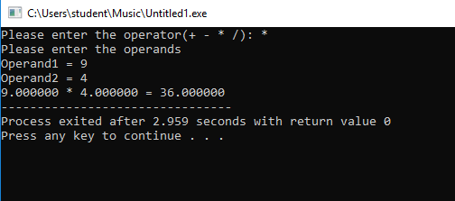

# Question #5

#include <stdio.h>

int main(){

float unit;

printf("Please enter units of electricity used: ");

scanf("%f",&unit);

if(unit>0 && unit<=50){

printf("Bill for this month is = %f", unit * 0.75);}

else if(unit>50 && unit<=150){

printf("Bill for this month is = %f", (unit - 50)*1.5 + 50 * 0.75);}

else if(unit>150 && unit<=250){

printf("Bills for this month is = %f",(unit - 150)* 1.75 + 100 * 1.5 + 50 * 0.75);}

else if(unit>250){

printf("Bills for this month is = %f", unit * 2);}

else printf("Invalid Input");

}

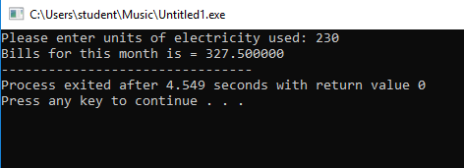

# Question #6

#include <stdio.h>

int main(){

float num1,num2,num3;

printf("Please enter three numbers");

printf("\nNumber 1 = ");

scanf("%f",&num1);

printf("Number 2 = ");

scanf("%f",&num2);

printf("Number 3 = ");

scanf("%f",&num3);

if (num1 == num2 && num2 == num3)

{

printf("All numbers are equal");

}

else if (num1 != num2 && num2 != num3 && num1 != num3)

{

printf("All numbers are different");

}

else printf("Neither all are equal nor different");

}

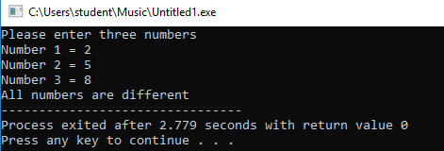

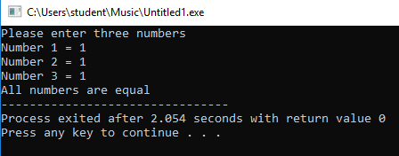

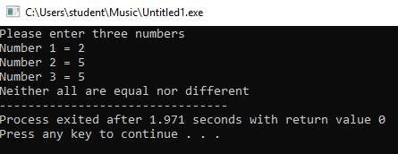

# Question #7

#include <stdio.h>

int main(){

//Q7

int num;

printf("Please enter number: ");

scanf("%d",&num);

switch(num){

case 1:

printf("one");

break;

case 2:

printf("two");

break;

case 3:

printf("three");

break;

case 4:

printf("four");

break;

case 5:

printf("five");

break;

case 6:

printf("six");

break;

case 7:

printf("seven");

break;

case 8:

printf("eight");

break;

case 9:

printf("nine");

break;

case 10:

printf("ten");

break;

default:

printf("Out of range");

}

}

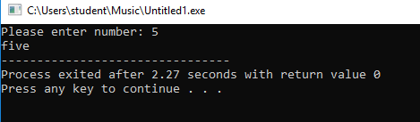

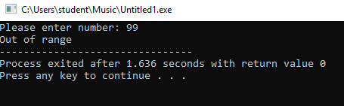

# Question #8

#include <stdio.h>

int main(){

//Q8

float dist;

printf("Please enter distance travelled = ");

scanf("%f",&dist);

if (dist>0 && dist<=100)

{

printf("Cost = 5”);

}

else if (dist>100 && dist<=500)

{

printf("Cost = 8");

}

else if (dist>500 && dist<=1000)

{

printf("Cost = 10");

}

else if (dist>1000)

{

printf("Cost = 12");

}

else printf("Invalid Input");

}

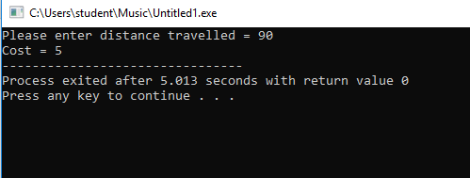

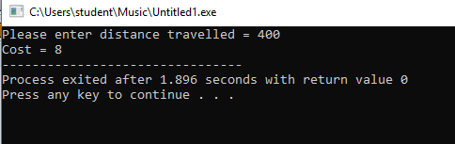

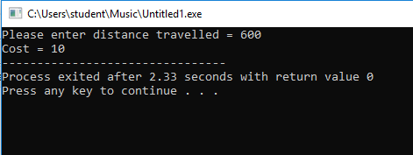

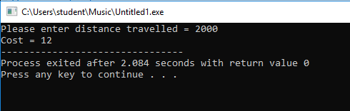

# Question #9

#include <stdio.h>

int main(){

//Q9

int num;

printf("Please enter a number: ");

scanf("%d", &num);

if (num%2 != 0)

{

num = num*3 + 1;

printf("The new value of the number is = %d", num);

}

else

{

num = num / 2;

printf("The new value of the number is = %d", num);

}

}

